COLLECTIBLE VINTAGE HANUKKAH MENORAHS
We have checked comparable Hanukkah Menorahs that are currently listed for sale on Ebay or Etsy (see prices listed in brackets). Depending on condition or seller, we discovered in certain cases a wide price range for the same item. When we found a range, we highlighted the price, which in our estimate best reflects the value of the item we are offering through our E-Mail Auction.
Please note all items are “sold as is”. Or Hadash Synagogue does not accept any liability, offer any warranty or guarantee accuracy for the products promoted. All sales are final.
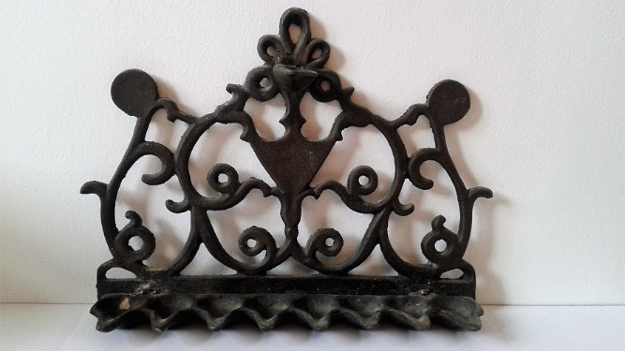  Starting bid $40  Buy-It-Now: $200 | #1  Rare, large Hanukkah Menorah from the 1950s or 1960s. Solid brass, very decorative.  Height: 8.0 in / 20.5 cm  Width: 11.1 in / 28.3 cm  Depth: 2.5 in / 6.0 cm  (Listed on Etsy for $660)  https://www.etsy.com/ca/listing/116607717/oil-lamps1960s-big-menorah-rare-1960s?ga_order=most_relevant&ga_search_type=vintage&ga_view_type=gallery&ga_search_query=menorah&ref=sr_gallery_7
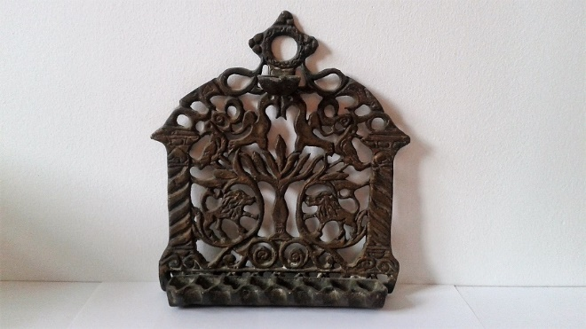  Starting bid $40  Buy-It-Now :$200 | #2  Copper alloy Hanukkah Menorah (early 1900s style) with spiral side columns supporting back plate in open framework, beautifully decorated with birds, lions and centered Synagogue Menorah.  Height: 8.1 in / 20.8 cm  Width: 7.5 in / 19.0 cm  Depth: 2.0 in / 4.5 cm  (Listed on Etsy $475-$528) $500  https://www.etsy.com/ca/listing/497315048/judaica-hanukkah-oil-menorah-heavy?ref=search_recently_viewed-3
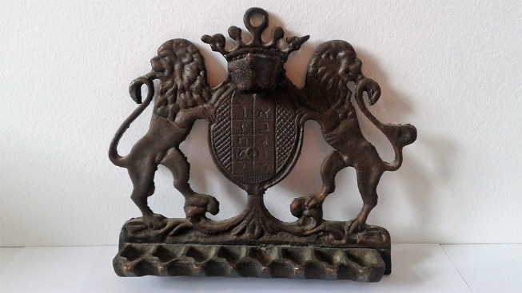  Starting bid $20  Buy-It-Now: $60 – SOLD! | # 3  Vintage bronze Hanukkah Menorah, “Lions of Zion”, wall hanging type but can also stand on any flat surface.  Height: 6.0 in /15.2cm  Width: 7.2 in / 18.3cm  Depth: 1.8 in / 4.5 cm  (Listed on Ebay $121 – US$165) $130  https://www.ebay.com/itm/Israel-Vtg-Jewish-Hanukkah-Menorah-solid-bronze-jerusalem-2-lion-oil-lamp/112517570833?hash=item1a3291e111:g:oIQAAOSwM7BZlVCq
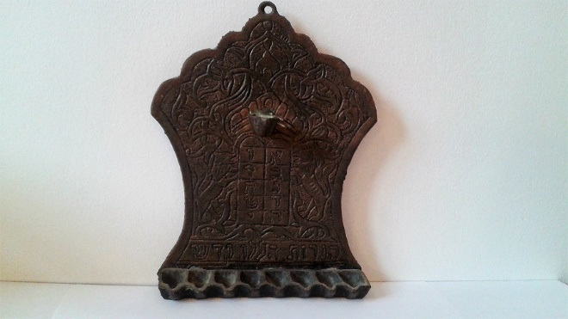  Starting bid $20  Buy-It-Now: $60 | #4  Solid brass Moroccan/African style Hanukkah Menorah from the 1950s with “Two Lions Zion Ark” motif, and Hebrew inscription at the bottom reading “Haneirot halalu kodesh”.  Height: 8.4 in / 21.0 cm  Width: 6.4 in / 16.0 cm  Depth: 1.7 in / 4.0 cm  Estimated value: $120
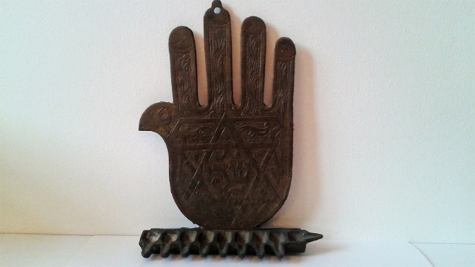  Starting bid $40  Buy-It-Now: $150 | #5  Gorgeous Tunisian brass Hamsa Hanukkah Menorah with Magen David and the word “Shadai” (in Hebrew) in its centre. (End of 19th century style).  Height: 8.00 in / 20.20 cm  Width: 5.75 in / 14.5 cm  Depth: 1.25 in / 3.2 cm  (Listed on Ebay for $290)  https://www.ebay.com/itm/Hamsa-Menorah-Hanukkah-Hand-Judaica-Magen-David-Star-Lamp-Antique-Candle-Holder/401340651679?hash=item5d71c4589f:g:c0MAAOSws5pZM6mS
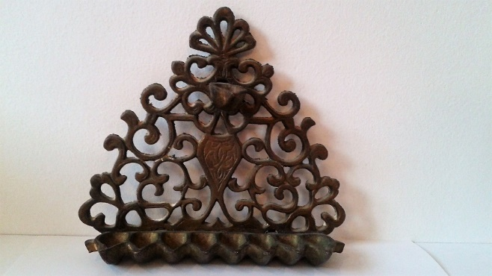  Starting bid $30  Buy-It-Now: $50 | #6  Filigree, very decorative floral Algerian or Moroccan vintage brass Hanukkah Menorah replica, made to hang on the wall.  Height: 6.5 in / 16.5 cm  Width: 7.4 in / 18.4 cm  Depth: 2.0 in / 4.5cm  (Listed on Ebay for $62 -$280) $150  https://www.ebay.com/itm/Vintage-Brass-Judaica-Hanukkah-Menorah-Wall-Mounted-Candles-oil-Heavy-Patina/322856456187?hash=item4b2bbe8ffb:g:OaQAAOSw7aBVDdtI
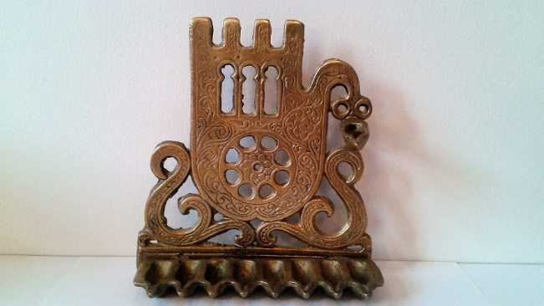  Starting bid $20  Buy-It-Now: $40 – SOLD! | #7  Lybian/North African vintage style brass Hamsa Hanukkah Menorah (1920s replica).  Height: 6.5 in / 16.5 cm  Width: 6.4 in / 16.0 cm  Depth: 2.4 in / 5.5 cm  (Listed on Ebay for $ 279) $90  https://www.ebay.com/itm/Menorah-Bronze-Libya-Vintage-Jewish-Hanukkah-Judaica-Bronze-Oil-Chanukah/162612812415?hash=item25dc7a9a7f:g:2yoAAOSwuMZZJpPh
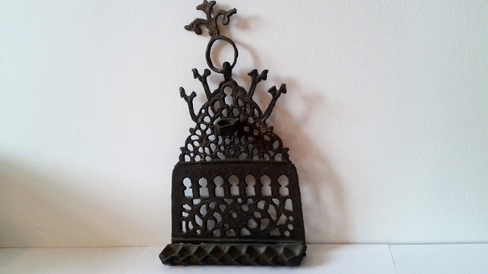  Starting bid $20  Buy-It-Now: $50 | #8  Moroccan style hanging vintage brass Hanukkah Menorah (1950s) with birds and hanging loop.  Height: 11.0 in / 28cm  Width: 6.2 in / 15.5cm  Depth: 1.8 in / 4.5 cm  (Listed on Ebay and Etsy $75 – $328) $120  https://www.etsy.com/ca/listing/163574690/oil-menorah1950s-vintage-menorah-50?ga_order=most_relevant&ga_search_type=vintage&ga_view_type=gallery&ga_search_query=menorah&ref=sr_gallery_7
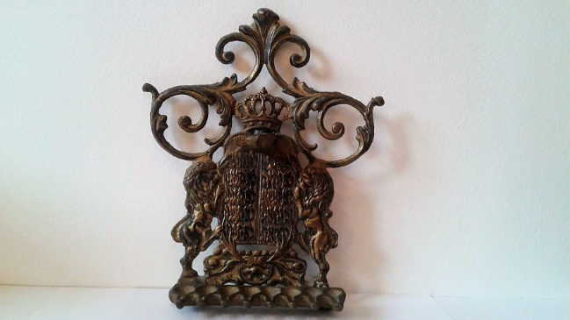  Starting bid $40  Buy-It-Now: $100 - SOLD | #9  Beautiful, rare hanging vintage brass Hanukkah Menorah with floral ornaments and the Two Lions Zion Ark, centering the Luchot HaBrit (Ten Commandments)  Height: 8.0 in / 20.5 cm  Width: 6.8 in / 17.0 cm  Depth: 1.8 in / 4.0 cm  Estimated value: $170
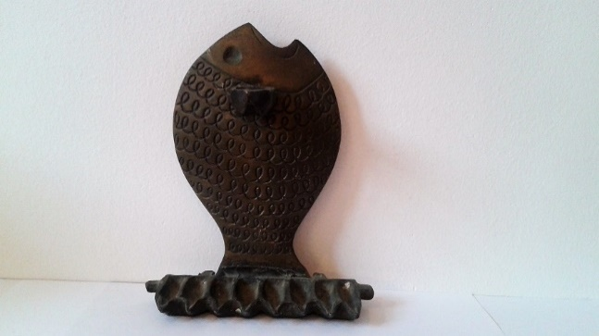  Starting bid $20  Buy-It-Now: $40 - SOLD | #10  Smaller, rare, collectible vintage brass Hanukkah Menorah. Charming Fish design. (Probably made in Israel in the 1950s).  Height: 6.2 in / 16.0 cm  Width: 5.5 in / 14.0 cm  Depth: 2.0 in / 5.0 cm  Estimated value: $90
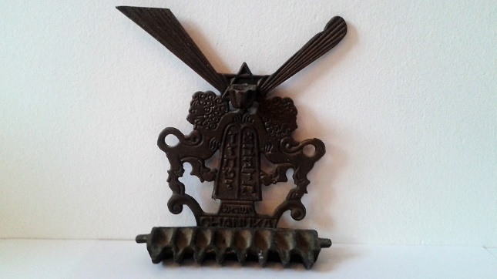  Starting bid $5  Buy-It-Now: $20 | #11  Small, vintage brass Hanukkah Menorah with Two Lions Zion Ark design, centering the luchot (Ten Commandments). Made in Israel (Probably in the 1960s or later).  Height: 5.2 in / 13.0 cm  Width: 4.8 in / 12.4 cm  Depth: 1.4 in / 3.5 cm  Estimated value: $35
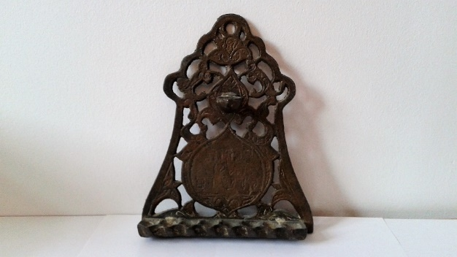  Starting bid $20  Buy-It-Now: $40 | #12  Moroccan/African style floral Hanukkah Menorah with Hebrew inscription in the middle reading “Haneirot halalu kodesh hem”.  Height: 8.4 in / 21.0 cm  Width: 6.4 in / 16.0 cm  Depth: 1.7 in / 4.0 cm  Estimated value: $90
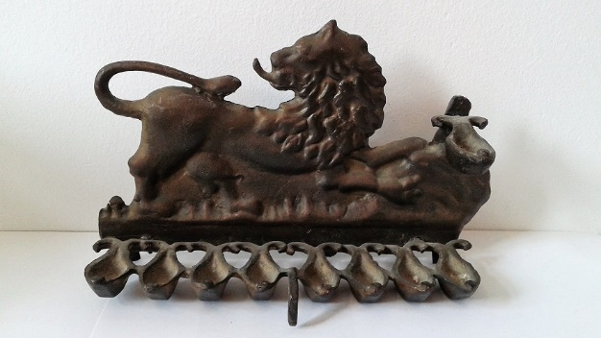  Starting bid $20  Buy-It-Now: $50 | #13  Dynamic “Rampant Lion of Juda” vintage brass Hanukkah Menorah for wall hanging.  Height: 5.0 in / 12.5 cm  Width: 8.1 in / 20.5 cm  Depth: 2.5 in / 6.0 cm  Estimated value: $110

